CAPITAL SMART CITY MARKETPLACE
Database Schema Design
Integrated Data Model — All Modules
Prepared for CEO Review
August 2026

1. Purpose of This Document
This document presents the integrated database schema that powers every module of the Capital Smart City Marketplace platform — public plot inventory, customer accounts, the Sell Property and Buy Property flows, token reservations and payments, document/KYC verification, final ownership confirmation, and Admin Portal oversight. It is designed to be read alongside PRD.md, Architecture.md, and Phases.md, and translates those product requirements into a concrete, implementable data model on Supabase (PostgreSQL).

2. How the Modules Map to the Schema
The schema is organized into seven functional groups, matching the platform's modules one-to-one. Every table in a group is owned conceptually by that module, but tables are connected across groups through foreign keys — this is what makes the platform a single, integrated system rather than disconnected pieces.
- Identity & Access — who the user is and what they're allowed to do (auth.users, profiles).
- Inventory — the plots, phases, pricing and amenities shown on the public map (phases, plots, payment_plans, amenities).
- Customer Engagement — saved plots and alerts (favorites, notifications).
- Sell Property — customer-submitted resale listings pending admin approval (listing_submissions).
- Buy / Reservation & Payments — token reservation and gateway payment tracking (reservations, transactions).
- Trust & Legal — KYC/ownership documents and the final confirmed ownership record (documents, ownership_records).
- Admin Oversight — a full audit trail of every verification and confirmation action (audit_logs).

3. Integrated Entity-Relationship Diagram
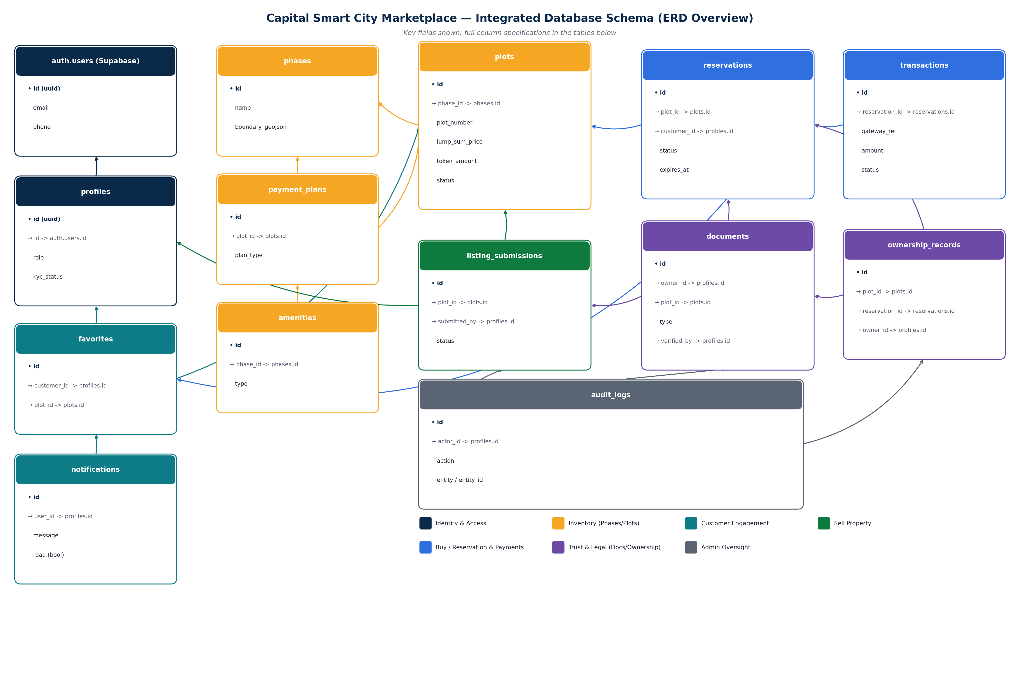

4. Detailed Table Specifications
Each table below lists its full column set, data types, and constraints, grouped by the module it belongs to.

4.1 Identity & Access
profiles — extends Supabase auth.users with platform-specific identity and role data.
Column | Type | Constraints | Description
PK id | uuid | = auth.users.id | Primary key, shared with Supabase Auth user
FK id | uuid | REFERENCES auth.users(id) | 1:1 link to the Supabase-managed auth record
full_name | text | NOT NULL | Customer or admin's full legal name
cnic_number | text | UNIQUE | National ID number, used for KYC matching
phone | text | UNIQUE, NOT NULL | Used for OTP verification
role | enum | customer / verification_officer / sales_admin / super_admin | Drives RBAC and RLS policies
kyc_status | enum | pending / verified / rejected | Gates whether user can reserve/buy a plot
created_at | timestamptz | DEFAULT now() | Account creation time

4.2 Inventory
phases — the geographic phase/sector boundaries shown on the map.
Column | Type | Constraints | Description
PK id | uuid | DEFAULT gen_random_uuid() | Primary key
society_id | uuid | reserved for multi-society support | Future-proofing beyond Capital Smart City
name | text | NOT NULL | e.g. "Phase 1", "Phase RVS"
boundary_geojson | jsonb | NOT NULL | Polygon outline rendered as the dashed phase boundary
town_plan_url | text | nullable | Link to the static Town Plan document/image
created_at | timestamptz | DEFAULT now() | —
plots — the core sellable unit; every reservation, listing, and ownership record ultimately points back here.
Column | Type | Constraints | Description
PK id | uuid | DEFAULT gen_random_uuid() | Primary key
FK phase_id | uuid | REFERENCES phases(id) | Which phase the plot belongs to
plot_number | text | NOT NULL | e.g. "Plot 24"
size | text | NOT NULL | e.g. "1 Kanal"
street | text | nullable | e.g. "St. 24"
zone | text | nullable | e.g. "5"
type | enum | residential / commercial | Drives the orange/blue map marker color
lump_sum_price | numeric(14,2) | NOT NULL | Full one-time price, in PKR
token_amount | numeric(14,2) | NOT NULL | Reservation-only token amount, in PKR
status | enum | available / reserved / under_verification / sold | Server-enforced state machine
rda_verified | boolean | DEFAULT false | Powers the "RDA Verified" badge
admin_verified | boolean | DEFAULT false | Powers the "Documents Verified by Admin" badge
latitude / longitude | numeric | NOT NULL | Map marker position
created_at / updated_at | timestamptz | DEFAULT now() | —
payment_plans — one or more instalment options attached to a plot.
Column | Type | Constraints | Description
PK id | uuid | DEFAULT gen_random_uuid() | Primary key
FK plot_id | uuid | REFERENCES plots(id) | Plot this plan applies to
plan_type | text | NOT NULL | e.g. "Lump Sum", "1 Year Plan"
installment_schedule | jsonb | nullable | Array of {period, amount} for instalment plans
amenities — map overlay layer (mosque, park, hospital, school icons).
Column | Type | Constraints | Description
PK id | uuid | DEFAULT gen_random_uuid() | Primary key
FK phase_id | uuid | REFERENCES phases(id), nullable | Optional phase association
type | enum | mosque / park / hospital / school / other | Determines the map icon
latitude / longitude | numeric | NOT NULL | Icon position on the map

4.3 Customer Engagement
Column | Type | Constraints | Description
PK id | uuid | DEFAULT gen_random_uuid() | favorites — primary key
FK customer_id | uuid | REFERENCES profiles(id) | Who saved the plot
FK plot_id | uuid | REFERENCES plots(id) | Which plot was saved
UNIQUE | — | (customer_id, plot_id) | Prevents duplicate saves
Column | Type | Constraints | Description
PK id | uuid | DEFAULT gen_random_uuid() | notifications — primary key
FK user_id | uuid | REFERENCES profiles(id) | Recipient
title / message | text | NOT NULL | Notification content
read | boolean | DEFAULT false | Read/unread state
created_at | timestamptz | DEFAULT now() | —

4.4 Sell Property Module
listing_submissions — a customer's request to list a plot they own for resale; nothing here is public until an admin approves it.
Column | Type | Constraints | Description
PK id | uuid | DEFAULT gen_random_uuid() | Primary key
FK plot_id | uuid | REFERENCES plots(id), nullable | Existing plot record, if already in inventory
FK submitted_by | uuid | REFERENCES profiles(id) | Customer making the submission
asking_price | numeric(14,2) | NOT NULL | Proposed resale price
status | enum | pending / approved / rejected | Admin review outcome
FK reviewed_by | uuid | REFERENCES profiles(id), nullable | Admin who reviewed it
review_notes | text | nullable | Reason for rejection, if any
created_at | timestamptz | DEFAULT now() | —

4.5 Buy / Reservation & Payments
reservations — created the moment a customer chooses to reserve a plot; the plot is locked to this customer while a reservation is active.
Column | Type | Constraints | Description
PK id | uuid | DEFAULT gen_random_uuid() | Primary key
FK plot_id | uuid | REFERENCES plots(id) | Plot being reserved
FK customer_id | uuid | REFERENCES profiles(id) | Reserving customer
token_amount_paid | numeric(14,2) | nullable until paid | Actual amount received from the gateway
status | enum | pending_payment / reserved / under_verification / confirmed / cancelled / expired | Server-driven state machine
expires_at | timestamptz | NOT NULL | Auto-release deadline if unpaid
created_at | timestamptz | DEFAULT now() | —
UNIQUE (partial) | — | plot_id WHERE status IN (reserved, under_verification) | Hard guarantee against double-booking the same plot
transactions — one row per payment attempt against a reservation, reconciled against gateway webhooks.
Column | Type | Constraints | Description
PK id | uuid | DEFAULT gen_random_uuid() | Primary key
FK reservation_id | uuid | REFERENCES reservations(id) | Reservation being paid for
gateway_ref | text | UNIQUE | Gateway's own transaction reference
amount | numeric(14,2) | NOT NULL | Amount charged, in PKR
status | enum | initiated / success / failed / refunded | Set only by the verified server-side webhook handler
raw_payload | jsonb | nullable | Raw gateway response, kept for reconciliation/audit
created_at | timestamptz | DEFAULT now() | —

4.6 Trust & Legal
documents — CNIC/KYC uploads and ownership/transfer paperwork, all stored in private buckets with signed-URL access only.
Column | Type | Constraints | Description
PK id | uuid | DEFAULT gen_random_uuid() | Primary key
FK owner_id | uuid | REFERENCES profiles(id) | Who uploaded the document
FK plot_id | uuid | REFERENCES plots(id), nullable | Related plot, if applicable
FK reservation_id | uuid | REFERENCES reservations(id), nullable | Related reservation, if applicable
type | enum | cnic / ownership_proof / transfer_deed / other | Document category
file_url | text | NOT NULL | Path in private Supabase Storage bucket
status | enum | pending / verified / rejected | Admin review outcome
FK verified_by | uuid | REFERENCES profiles(id), nullable | Admin who verified it
verified_at | timestamptz | nullable | —
ownership_records — the final, admin-confirmed record of who owns which plot; this is what powers the customer's "My Property" tab.
Column | Type | Constraints | Description
PK id | uuid | DEFAULT gen_random_uuid() | Primary key
FK plot_id | uuid | UNIQUE, REFERENCES plots(id) | One confirmed owner per plot
FK reservation_id | uuid | REFERENCES reservations(id) | Reservation that led to this ownership
FK owner_id | uuid | REFERENCES profiles(id) | Confirmed owner
FK confirmed_by | uuid | REFERENCES profiles(id) | Admin who gave final sale confirmation
confirmed_at | timestamptz | NOT NULL | Legal confirmation timestamp

4.7 Admin Oversight
audit_logs — an immutable trail of every verification, approval, and sale-confirmation action taken by any admin, for legal traceability.
Column | Type | Constraints | Description
PK id | uuid | DEFAULT gen_random_uuid() | Primary key
FK actor_id | uuid | REFERENCES profiles(id) | Admin who performed the action
action | text | NOT NULL | e.g. "document.verified", "sale.confirmed"
entity / entity_id | text / uuid | NOT NULL | Which record the action applied to
metadata | jsonb | nullable | Before/after values or extra context
created_at | timestamptz | DEFAULT now() | —

5. Cross-Module Relationship Summary
This is the connective tissue that makes the platform one integrated system: a single plot flows through inventory, sell/buy, payment, verification, and final ownership without ever leaving a consistent data trail.
From | Cardinality | To | Meaning
plots | N : 1 | phases | Every plot belongs to exactly one phase
payment_plans | N : 1 | plots | A plot may offer several payment plans
listing_submissions | N : 1 | plots / profiles | A customer submits a plot for resale
reservations | N : 1 | plots / profiles | A customer reserves one plot at a time
transactions | N : 1 | reservations | Each payment attempt is tied to one reservation
documents | N : 1 | profiles / plots | KYC and ownership docs, owned by a user
ownership_records | 1 : 1 | plots | Exactly one confirmed owner per plot
audit_logs | N : 1 | profiles | Every admin action is attributed to an actor

6. Security Model Summary
Every table above is protected by Supabase Row Level Security (RLS). The general pattern applied across the schema:
- Public/anonymous role: read-only access to phases, plots, payment_plans, amenities where the plot is publicly listed — no write access anywhere.
- Customer role: full read/write on their own profiles, favorites, notifications, listing_submissions, reservations, transactions (read-only), and documents — never another user's rows.
- Admin roles: elevated policies (via a role check in profiles) granting write access to verification, reservation confirmation, ownership_records, and inventory management — enforced through server-side routes using the Supabase service role, never the anon key.
- audit_logs is insert-only for admins and never editable or deletable by any role, preserving a tamper-evident legal trail.
- Plot double-booking is prevented at the database level with a partial unique index, not just application logic — so it holds even under concurrent requests.

